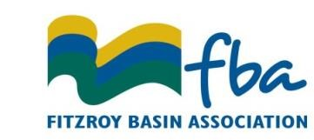
Market Certification System Audit Reimbursement Form

Property  Owner/Manager Details  Preferred method / time  of contact –  ................................... | Full name/s:
 | Phone:
 | Mobile:
 | Fax:
 | Email:
Postal address:
City/Town:
Postcode:
Property name:
Property size:  (hectares or acres) | Ha |  |  | Acres
Lot and Plan numbers:
Trading Name:
ABN:
GST Registered: | ◻ Yes |  | ◻ No
Payment Method: | ◻ Direct deposit (EFT) |  | ◻ Cheque
Bank Details: | BSB: |  | A/c No:
 | Account Name:

MARKET CERTIFICATION SYSTEM AUDIT DETAILS
Date Audit Conducted:
Name/s of Attendees:
Business Name of Audit Company:
Name of Market Certification System:
To claim for a market certification system audit you will need to create a tax invoice made out to:
Fitzroy Basin Association, PO BOX 139, Rockhampton QLD 4700 ABN: 30 802 469 401
The Tax invoice should be made out to the value of 70% of the audit cost capped at $700
Audit reimbursement claim forms and associated documents must be received by FBA no later than
30 days after the audit is conducted
Supporting documents required:  - Receipt from audit company  - Copy of Audit Certificate  - Copy of Grazing BMP 5 Module Completion Certificate  - Tax invoice made out to FBA |  |  |  |  |  |  | Office Use Only
Have you made a training or market certification system audit reimbursement claim in the past 12 months? |  |  |  |  |  |  | ◻ Yes  ◻ No

